**Xpath Basic**

Login to : 'https://www.phptravels.net/admin-portal/admin

User/PW: [admin@phptravels.com/demoadmin](mailto:admin@phptravels.com/demoadmin)

Capture 2 elements for each control (Anywhere on Web application):

1. Checkbox

2. Menu

3. Button

4. Label

5.Textbox

6. Link

7.Image

8.Icon

9.Tab

10.Combobox

11.Table

**Xpath Advance**

1. **Button**

Capture ‘Website’, ‘Delete Selected’, ‘Search’ and ‘Reset Chart’ button

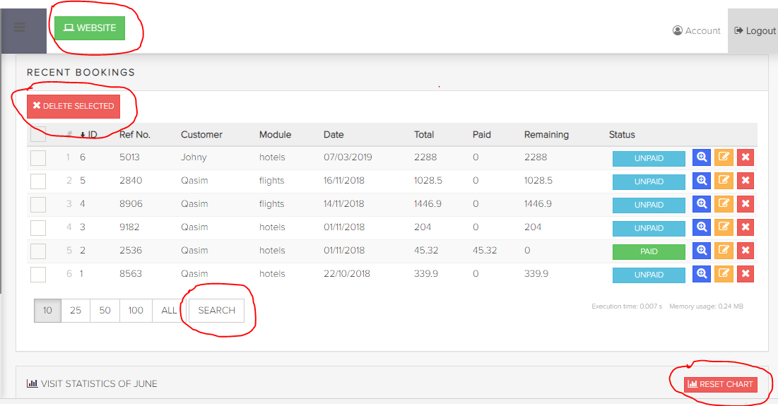

1. **Menu bar**

Capture ‘HOTELS’ Main menu; ‘HOTELS’, ‘EXTRAS’, ‘REVIEW’ sub menu

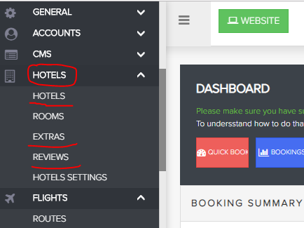

1. **Menu Item**

Capture Main menu that has 6 menu items => ‘FLIGHTS’

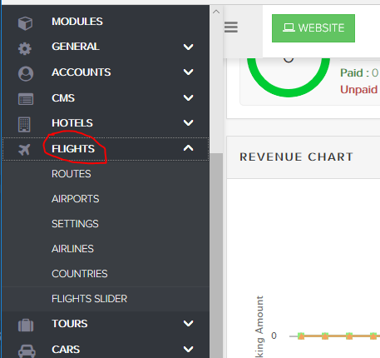

1. **Number**

Capture ‘Total Admins’, ‘Total Customers‘, and ‘Total Bookings’ number

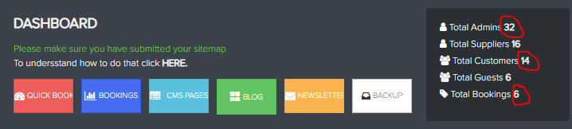

1. **Icon**

Capture ‘Hotels’, ‘Flights‘, ‘Tours’ and ‘Cars’ icon

## 

1. **List Cells**

Capture list Cells ‘Ref No’ that ID number is greater than 3

## 

1. **Checkbox Cell**

Capture Checkbox Cell that Status is ‘PAID’

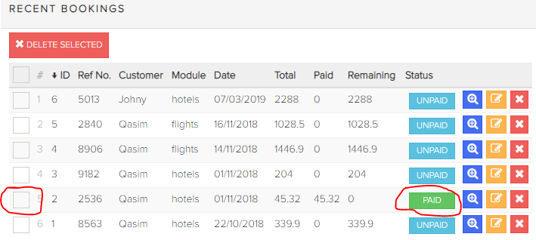

1. **Icon on Cell**

Capture Delete icon on Cell that ‘Ref No’ is ‘8906’

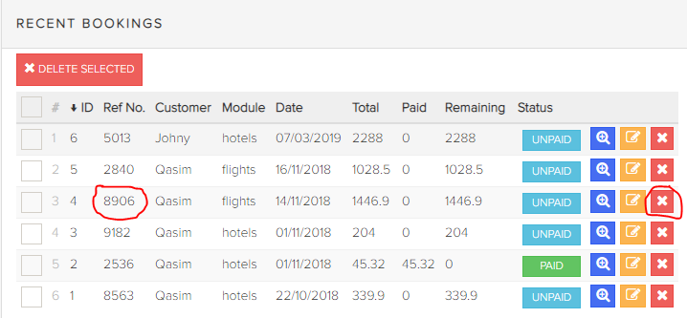

1. **Label on Cell**

Capture Label on ‘Paid’ column that Number is not 0

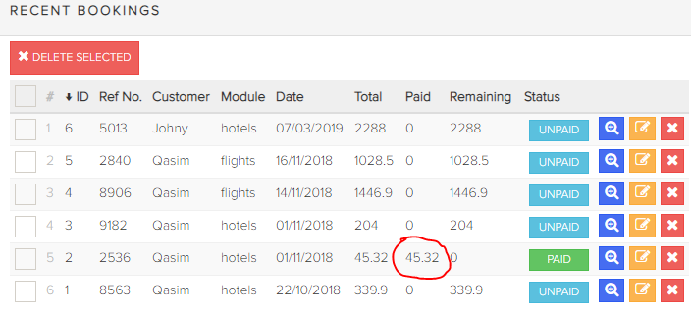

1. **Link on Cell**

Select HOTELS/HOTELS menu bar

Capture 'Rendezvous Hotels' hotel is 2 Starts

Capture ‘Hyatt Regency Perth' hotel is 3 Start

